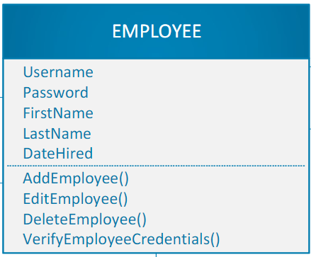

**Employee Table**

Username – varchar(25)

Password – varchar(25)

FirstName – varchar(25)

LastName - varchar(25)

Date_Hired – date

The employee table will consist of the employee’s information, including first and last name as well as their username and password along with the date they were hired. We decided on the varchar data type with 25 characters allocated because of its relatively small size and versatility, however, the date hired attribute will be a date type.

**Machine Table**

MachineName – varchar(25)

Serial – varchar(25)

Location – varchar(25)

PurchaseDate – date

The Machine table will be the main inventory table for the SRC, and it will allow for all the important data points about each machine to be stored in a single table. This way, simple queries can be executed to find out the most pressing information (“Which machines did we buy in 2018?”, “What machines do we have in the main floor area of the gym?”, etc.)

**Locker Table**

LockerID – varchar(25)

Gender – char(1)

LockerSize – varchar(25)

Available – bit

MemberID – varchar(25)

This Locker table will include details about the individual lockers, including the locker’s ID number, its availability status (true or false), its size and the gender locker room it is assigned to. The MemberID attribute is a foreign key here but is the primary key in the Member table. The same thing can be said about the LockerID here (PK) and in the Member table (FK).